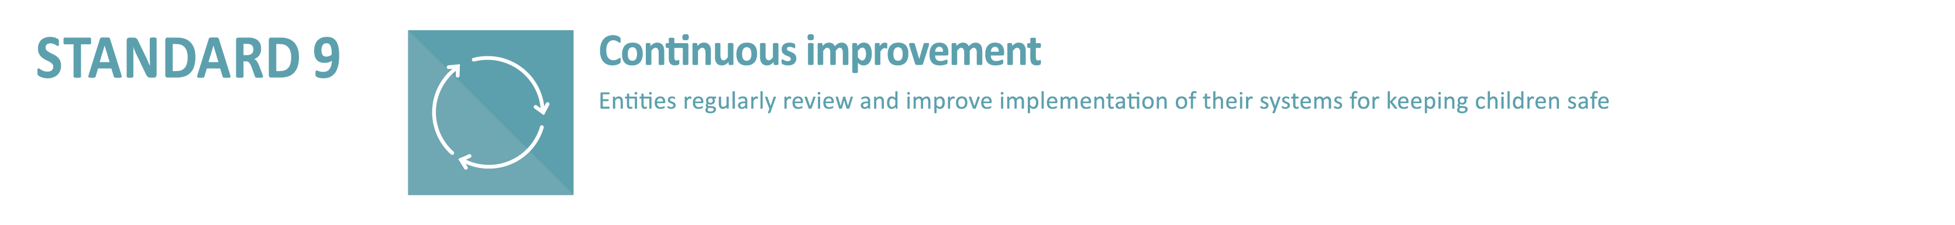

9.1.1 The entity has a clearly documented Safeguarding Implementation Plan which outlines the monitoring and continual improvement of child safeguarding practices. The Safeguarding Implementation Plan is regularly reviewed, progress is tracked and actions/strategies updated.
Safeguarding Action Plan template
Standard/Criteria | Actions/Notes  WHAT needs to be done to achieve the desired outcome | By whom  WHO is responsible | Completion date  By WHEN | Evidence  Supporting documents of work undertaken
Standard 1: Committed leadership, governance & culture
1.1 A commitment to safeguarding with zero tolerance
1.2 Promoting a Safeguarding Culture/Safeguarding Committee/Safeguarding coordinator
  - Safeguarding Policies
  - Code of Conduct
  - Risk management strategies to prevent, identify & mitigate risks to children
1.6 Obligations re: information sharing & record keeping are understood

Standard 2: Children are safe, informed and participate
2.1 Children are informed about their rights
2.2 Children are supported in friendships & relationships
2.3 Abuse prevention training is offered as appropriate
2.4 Personnel are skilled to recognise signs of harm & support children to raise concerns

Standard 3: Partnering with families, carers & the community
3.1 Families & carers participate in decisions affecting their child
3.2 Families, carers & communities are informed & involved in safeguarding approaches
3.3 Families, carers & communities have a say in the entity’s policies & practices
3.4 Families, carers & communities are informed about the entity’s operations & governance
3.5 The entity takes a leadership role in raising community awareness of the dignity & rights of all children

Standard 4: Equity is promoted & diversity is respected
4.1 Children’s diverse circumstances & backgrounds are catered for
4.2 Information, support & complaints processes are accessible
4.3 Aboriginal & Torres Strait Islander children, children with disability, & children from diverse backgrounds are given particular attention

Standard 5: Robust human resource management
5.1 Child-safe recruitment
5.2 Background checks & WWCC for personnel
5.3 Induction
5.4 Supervision & people management
5.5 Initial & on-going formation for clergy & religious
5.6 Seminary & formation programs build safeguarding skills
5.7 Credentialing & movement of seminarians, clergy & religious
5.8 Overseas clergy

Standard 6: Effective complaints management
6.1 Complaints handling policy
6.2 Child-focused system
6.3 Complaints are taken seriously & managed appropriately
6.4 Clear reporting procedures
6.5 Privacy & legal requirements
6.6 Care for adult complainants
6.7 Support for respondents

Standard 7: Ongoing education & training
7.1 To effectively implement Safeguarding policies & procedures
Minimum requirements: Code of Conduct (1.1.1), Safeguarding risk management (1.5), Safeguarding Policy & procedures (1.1.1), Complaints Handling Policy & procedures (Std 6), Reporting obligations (Std 6), e-safety training (Std8)
7.2 To recognise child abuse
7.3 To respond to safeguarding risks, concerns, disclosures & allegations
7.4 To build culturally safe environments for children

Standard 8: Safe physical & online environments
8.1 Identify & mitigate risks (online & physical)
8.2 Code of Conduct & safeguarding systems cover online use
8.3 Risk management plans covering settings, activities & physical environments
8.4 Agreements with third parties cover safeguarding
Standard 9: Continuous improvement
9.1 Regular review & improvement
9.2 Identify causes/failures to inform improvement
9.3 Report review findings to personnel, children, families, carers & community
Standard 10: Polies & procedures support child safety
10.1 Policies & procedures address the NCSS
10.2 Policies & procedures are accessible & easy to understand
10.3 Best practice informs development & review
10.4 Leaders promote & comply with policies & procedures
10.5 Personnel understand & implement policies & procedures

