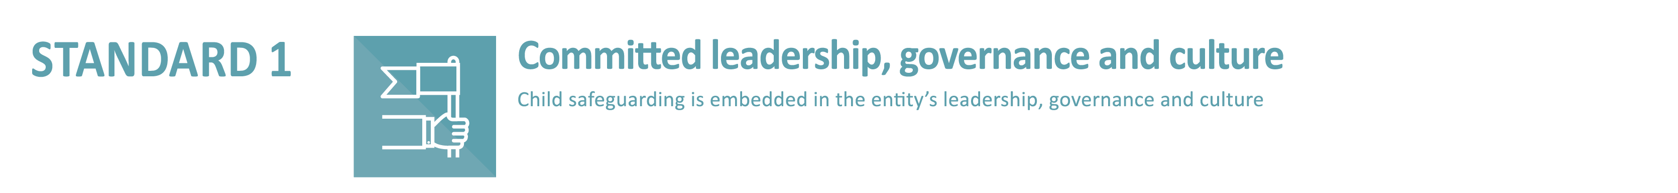

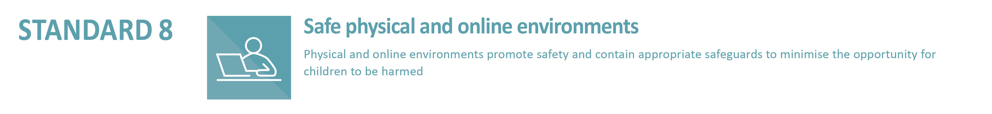
1.5.1 The entity has a clearly documented child safeguarding risk management plan, as part of its overall risk management strategy, which considers actual and potential risks relating to children.

8.1.1 The entity’s safeguarding risk management plan [refer to Indicator 1.5.1] addresses the physical and online risks including risks arising from child-to-child and adult-to-child interactions, and the nature of physical spaces.
8.3.1 The entity assesses and mitigates safeguarding risks in the physical environments under its control and/or management, including buildings, structures, open spaces, grounds, homes of religious and clergy, and arrangements for live-in carers/caretakers.
Risk management plan template
IDENTIFY RISK |  | ASSESS RISK |  |  | MANAGE RISK
Category | Description | Likelihood | Consequence | Risk Level | Management Actions

