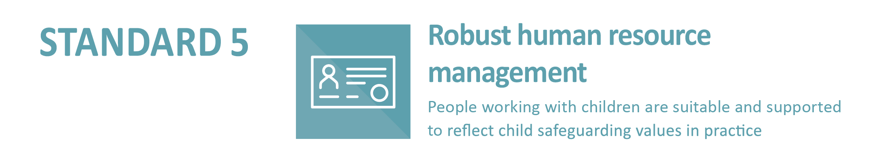
5.1.4 Position descriptions, selection criteria, referee checks and interview questions articulate:
- that children are valued and respected;
- the commitment of the entity to child safeguarding; and
- where appropriate to the role [refer to Indicator 5.1.3], an understanding of children’s developmental needs and culturally safe practices.
Sample Applicant Declaration for use when screening applicants for work with children. All applicants for work with children could be required to complete this declaration as part of the application process.
CHILD SAFE APPLICANT DECLARATION

SECTION 1: PERSONAL DETAILS
Surname: |  |  |  |  | Mobile:
Given Name(s): |  |  |  |  | Home Phone:
Title: |  |  | Email:
Previous name(s):
Residential Address:  Postcode: |  |  |  |  | Mailing Address:  Postcode:
Date of Birth: |  |  |  | Australian Resident: If NO, Visa Status:  If Visa, Visa Number/Class:  Country of Citizenship: |  | Yes No
Place of Birth:
(City, State, Country)
Are you of Aboriginal or Torres Strait islander origin? No Aboriginal Torres Strait Islander
(Persons of both Aboriginal and Torres Strait islander origin should mark BOTH boxes)

SECTION 2: EMPLOYMENT / VOLUNTEERING RECORD
Please include a full employment history including any employment gaps and provide a reason for the gap/s from the date of your first employment. (If you need more space, please attach another page to this document)
Occupation | Employer | Year |  | Reason for leaving
 |  | From | To

SECTION 3: EMPLOYMENT / VOLUNTEER CHECKING
All applicants are required to answer the following questions.
1. Have you been convicted of an offence that would prevent you from undertaking work with children?
Yes No
If YES, please give brief description

2. Are you currently subject to any criminal proceedings that if proven would prevent you from undertaking work with children?
Yes No
If YES, please give brief description

3. Have you ever been the subject of a serious allegation involving your conduct with a child or young person, such as a sexual offence, sexual misconduct, assault, ill-treatment, neglect or psychological harm that resulted in a notification to a statutory authority under local reportable conduct or child protection legislation?
Yes No
If YES, please give brief description

4. Have you ever been the subject of a complaint or allegation and/or internal investigation that related to a breach of your professional boundaries and/or breach of a Code of Conduct?
Yes No
If YES, please give brief description

5. Are you aware of any reason or concern, held by another person, which may make you unsuitable to work with children?
Yes No
If YES, please give brief description

6. Have you ever been the subject of an Apprehended Violence Order (AVO) that was made for the purpose of protecting a child or young person from harm?
Yes No
If YES, please give brief description

NOTE: THE FOLLOWING CHECK IS REQUIRED IF YOU ARE THE PREFERRED APPLICANT
Working with Children Check
This position is for child-related work, and as such you much obtain and retain a Working with Children Check from the [insert relevant statutory authority responsible for the legislated working with children check or equivalent].
For further details refer to [insert relevant website for statutory authority].
[Insert name of Church entity] will NOT finalise the application / appointment to the role until you provide [Insert name of Church entity] with proof of a current, valid Working with Children Check.

SECTION 4: OTHER EMPLOYMENT / VOLUNTEER CHECK QUESTIONS
All applicants are required to answer the following questions.
7. Have you ever been charged with any criminal offence?
Yes No
If YES, please give brief description

8. Have you ever been convicted of any criminal offence?
Yes No
If YES, please give brief description
9. During the last five (5) years have you been the subject of formal performance management and/or disciplinary proceedings (or any action that might lead to such proceedings) in relation to your employment?
Yes No
If YES, please give brief description
10. As a result of such proceedings or for any reason, have you ever been suspended, dismissed or asked to resign from your position?
Yes No
If YES, please give brief description

SECTION 5: NOMINATED REFEREES
It is policy of [Insert name of Church entity] for applicants for all positions to provide the names of at least two professional referees, including their most recent employer.
MOST RECENT EMPLOYER
Name: |  | Position:
Organisation: |  | Email:
Phone: |  | Mobile:
SECOND REFEREE
Name: |  | Position:
Organisation: |  | Email:
Phone: |  | Mobile:
I understand that [Insert name of Church entity] reserves the right to contact any previous employer other than the referees nominated above:

Applicant Signature: Date:

SECTION 6: APPLICANT DECLARATIONS
Employment/volunteering with [Insert name of Church entity] is child-related work. By submitting this application, I am agreeing that there is no reason for the [Insert name of Church entity] to believe I am not suitable to work in child-related employment. If any information not disclosed in this application is brought to the attention of [Insert name of Church entity], my application may be reviewed and/or employment may be terminated.

Applicant Signature: Date:
In addition, I certify that the information provided in this application form Child Safe Applicant Declaration is complete and correct in every detail, and I understand that deliberate inaccuracies or omissions may result in non-acceptance of my application and/or termination of employment.

Applicant Signature: Date:

Adapted from Application to teach form, Sydney Catholic Schools, www.sydcatholicschools.nsw.edu.au

